

Assignment 1

MLB_11.01_09

**Online Teacher Trainer**

Software Process Modeling-I

**IT1060 – Software Process Modeling Semester 2**

**Year 01 Semester II**- **2023**

|  |  |
| --- | --- |
| **PROJECT ID** | MLB_11.01_09 |
| **CASE STUDY NAME** | Online Teacher Trainer |
| **CAMPUS/CENTER** | SLIIT/Malabe |

**Group Details:**

|  |  |  |
| --- | --- | --- |
|  | **Student Registration Number** | **Student Name** |
| **1** | IT22102782 | Afzal Ahamed A H |
| **2** | IT22149626 | Chandrasiri G A S D |
| **3** | IT22150448 | Kaushalya W M D S |
| **4** | IT22144430 | Liyanage N S |
| **5** | IT22153654 | Piranavan S |

**We hereby certify,**

🗹 The attached is our own work and no further changes will be made.

🗹 We have contributed in this assignment to the best of our ability.

And we understand,

🗹 We may be subject to student discipline processes in the event of an act of academic misconduct by us including an act of plagiarism or cheating

|  |  |  |  |  |
| --- | --- | --- | --- | --- |
|  | **Student Name** | **Student Registration**  **Number** | **Date** | **Signature** |
| **1** | Afzal Ahamed AH | IT22102782 | 24/04/2023 |  |
| **2** | Chandrasiri G A S | IT22149626 | 24/04/2023 |  |
| **3** | Kaushalya WMDS | IT22150448 | 24/04/2023 |  |
| **4** | Liyanage N S | IT22144430 | 24/04/2023 |  |
| **5** | Piranavan S | IT22153654 | 24/04/2023 |  |

**Introduction**

The most recent advancement in teacher training is an online teacher trainer system.

Because you can access as many courses as you want and can train your knowledge at any time and from anywhere. We update our system on a daily basis. Our New Guru online teacher trainer is specifically designed for instructors and people in training who are willing to study new courses and learn more about how to manage new information technology usable items. A 24-hour customer helpline is also available. We are the internationally reformed online teacher trainer system, and we make sure that every element is made clear to our users.

Additionally, it aids in teaching at prestigious universities. It aids teachers in achieving their goals. Your stress from looking for high-quality research is lessened by our new expert.

**Assumption**

We have decided to introduce this “Teacher trainer app” in order to develop the knowledge of the teachers through an online platform. So that, it is able to access easily rather than going for physical learning ways. It also helps to save time and able to learn anytime.

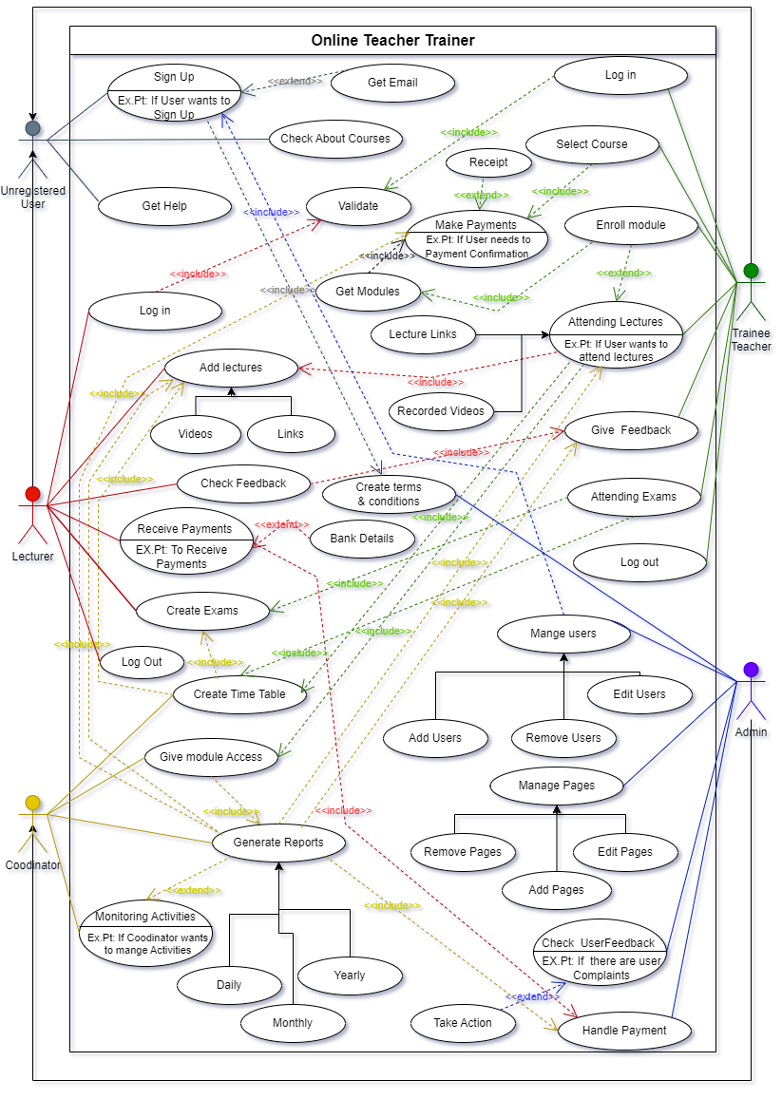

**IT22102782 Afzal Ahamed AH**

**Section Worked on:**

* Designed the use case diagram for the actor “lecturer”.
* Designed a use case scenario for the Lecturer.

**Special Contribution:**

* Give ideas on use case diagram.
* Gathered everyone’s idea.
* Collect each group member’s parts and create the final report of the project.

**Challenges faced:**

* Took a little more time to understand the concepts of the topic.
* Difficulties regarding collecting relevant details.
* Faced trouble allocating time for the assignment because of mid examinations.

|  |  |  |
| --- | --- | --- |
| **IT22102782** | | |
| **Use case ID** | OTT_L_1 | |
| **Use case Name** | Add video | |
| **Summary** | Adding previous lecture videos and links | |
| **Priority** | 1 | |
| **Preconditions** | Lecturer needs to sign in his or her account | |
| **Primary Actor(s)** | lecturer | |
| **Trigger** | Lecturer has chosen to train trainee teacher through their videos and links | |
| **Main Scenario** | **Step** | **Action** |
| **1** | Go to the Online Teacher Trainer page. |
| **2** | log in as lecturer |
| **3** | System check the Lecturer account details |
| **4** | Lecturer uploads the videos and tutorials |
| **5** | Lecturer can check the videos which are uploaded |
| **6** | Log out as lecture |
| **Extensions** | **Step** | **System Action** |
| **5a** | If There any issues on uploaded videos and link. Go to coordinator |
| **Open Issues** | **-** | - |

|  |  |  |
| --- | --- | --- |
| **IT22102782** | | |
| **Use case ID** | OTT_L_2 | |
| **Use case Name** | Receive payments | |
| **Summary** | The lecturer receives the payments | |
| **Priority** | 4 | |
| **Preconditions** | The lecturer has logged into receive payment page | |
| **Primary Actor(s)** | Lecturer | |
| **Trigger** | had to be paid for conducting the online lecture | |
| **Main Scenario** | **Step** | **Action** |
| **1** | Go to the Online Teacher Trainer page. |
| **2** | Login as the lecturer |
| **3** | go to the payment page |
| **4** | It will offer various payment options. |
| **5** | Select the payment option. |
| **6** | Lecturer needs to receive the payments. |
| **7** | Proceed to the checkout the payment received. |
| **8** | Log out as the lecturer. |
| **Extensions** | **Step** | **System Action** |
| **6a** | Show a notification if payment is unsuccessful |
| **Open Issues** | **5** | Should the system ask if the lecturer needs a confirmation email? |

**Kaushalya WMDS – IT22150448**

**section worked on:**

* Designed use cases for the "Trainee Teacher" actor.
* Designed table for the use cases.

**Special contribution:**

* Writing the introduction of the use case diagram for Edu Teach Online Teacher Trainer System.
* Proofreading of the assignment.

**Challenges faced:**

Since drawing use case diagram lecture is in the last week of 1st half of the semester, we had mostly one week to complete our assignment. So managing time within a week was a major challenge we’ve faced during the assignment.

|  |  |  |
| --- | --- | --- |
| **IT22150448** | | |
| **Use case ID** | OTT_TT_1 | |
| **Use case Name** | Attending lectures | |
| **Summary** | Attending enrolled modules’ lectures | |
| **Priority** | 1 | |
| **Preconditions** | User should registered to the system | |
| **Primary Actor(s)** | Trainee Teacher | |
| **Trigger** | The user wanted to get trained through online training system | |
| **Main Scenario** | **Step** | **Action** |
| **1** | User selects ‘Enroll Module’ option. |
| **2** | System display course(s) selected by the user. |
| **3** | User clicks on ‘Enroll Module’. |
| **4** | System asks user to enter module code. |
| **5** | User enters module code. |
| **6** | System enroll user to the selected module. |
| **7** | System displays module details, lecture notes, lecture videos and links. |
| **8** | User chooses lecture video(s) which he/she wanted to attend. |
| **9** | Download lecture notes, watch videos, attending live lectures. |
| **10** | Complete module. |
| **Extensions** | **Step** | **System Action** |
| **5a** | If module code is incorrect, system asks user to re-enter the code. |
| **Open Issues** | **-** | - |

|  |  |  |
| --- | --- | --- |
| **IT22150448** | | |
| **Use case ID** | OTT_TT_2 | |
| **Use case Name** | Select Course | |
| **Summary** | User selects course(s) | |
| **Priority** | 1 | |
| **Preconditions** | User should sign up to the system | |
| **Primary Actor(s)** | Trainee Teacher | |
| **Trigger** | User wanted to learn through the system | |
| **Main Scenario** | **Step** | **Action** |
| **1** | User clicks on ‘Select Course’. |
| **2** | System displays available courses. |
| **3** | User selects the course(s). |
| **4** | System redirects to the payment gateway page. |
| **5** | User makes payment. |
| **6** | System issues payment receipt |
| **Extensions** | **Step** | **System Action** |
| **3a** | If the course that user wanted is unavailable, system ask user to exit option. |
| **5a** | If the user inputs invalid details to the payment gateway, system will automatically exit the gateway. |
| **Open Issues** | **1** | Should system suggest relevant courses to the user? |

**IT22153654 - Piranavan S**

**Section worked on**

* Draw the use case diagram by using draw io software.
* Design the use case diagram together with the team members.
* Defined the use case, Generalization, include and extend of the Manager.

**Special contribution on:**

* Shared Ideas among the Group members about the Use cases.
* Explained to team members what is use case and how to draw them.
* Found some errors in the use case of the team members and fix them.
* Worked as a team to combine the whole use case diagram.

**Challenges faced:**

* Difficult to find the relations among the use cases.
* As a basic student to draw.io, it was bit harder to draw use case diagram.

|  |  |  |
| --- | --- | --- |
| **IT22153654** | | |
| **Use case ID** | OTT_C_1 | |
| **Use case Name** | Create timetable | |
| **Summary** | Give the timetable | |
| **Priority** | 1 | |
| **Preconditions** | Lecturer needs to login his or her account | |
| **Primary Actor(s)** | Coordinator | |
| **Trigger** | Trainee teachers to follow their lecture properly | |
| **Main Scenario** | **Step** | **Action** |
| **1** | Login to the database |
| **2** | Enter the User Data Folder |
| **3** | Gather all user data files |
| **4** | Create the lecture timetable |
| **5** | Give the module access to lecturer |
| **Extensions** | **Step** | **System Action** |
| **3a** | If the email is not valid, the system prompts an error |
| **Open Issues** | **-** | _ |

|  |  |  |
| --- | --- | --- |
| **IT22153654** | | |
| **Use case ID** | OTT_C_2 | |
| **Use case Name** | Give module access | |
| **Summary** | Provides module to access online teacher trainer | |
| **Priority** | 2 | |
| **Preconditions** | The user must confirm that their username and password are correct. | |
| **Primary Actor(s)** | Coordinator | |
| **Trigger** | Trainee teachers wanted to get their module access | |
| **Main Scenario** | **Step** | **Action** |
| **1** | Select sign-in as Trainee Teacher or Lecturer |
| **2** | Sign in with an Email |
| **3** | Fill the form |
| **4** | Select Course or Modules (Trainee Teacher selects a Course  hope to learn and Lecturer selects Modules to hope to teach) |
| **5** | Accept Terms and Conditions |
| **6** | Submit details |
| **Extensions** | **Step** | **System Action** |
| **3a** | If the email is not valid, the system prompts an error |
| **Open Issues** | **1** | Should the system ask if the user is conﬁdent about the information ﬁlled |

**IT22144430 - Liyanage N S**

**Section worked on:**

* Drawing the use case diagram.
* Draw a use case scenario for the Unregister user and trainee Teacher.

**Special contribution on:**

* Help others to complete their use case scenario.
* Help others to create use cases.

**Challenges Faced:**

* Difficult to find the relations among the use cases.
* Difficult to gather group members.

|  |  |  |
| --- | --- | --- |
| **IT22144430** | | |
| **Use case ID** | OTT_UU_1 | |
| **Use case Name** | Sign Up | |
| **Summary** | Registration of Trainee Teachers and Lecturers | |
| **Priority** | 1 | |
| **Preconditions** | The user should have a valid email | |
| **Primary Actor(s)** | Unregistered User | |
| **Trigger** | The user wanted to register for the online Teacher Trainer System | |
| **Main Scenario** | **Step** | **Action** |
| **1** | Go to the online teacher trainer |
| **2** | Select sign-in as Trainee Teacher or Lecturer |
| **3** | Sign in with an Email and Password |
| **4** | Enter the following information on the webpage as required by the user,   * First name * Last name * Address * NIC * Mobile Number |
| **5** | Select Course or Modules (Trainee Teacher selects a Course hope to learn and Lecturer selects Modules to hope to teach) |
| **6** | Accept Terms and Conditions |
| **7** | Click on Submit button to Submit details |
| **Extensions** | **Step** | **System Action** |
| **3a** | If the email is not valid, the system prompts an error |
| **7a** | If the user wants to submit the form, the system prompts a confirmation |

|  |  |  |
| --- | --- | --- |
| **Open Issues** | **7** | Should the system ask if the user wants to read the terms and conditions? |

|  |  |  |
| --- | --- | --- |
| **IT22144430** | | |
| **Use case ID** | OTT_TT_3 | |
| **Use case Name** | Attending Exams | |
| **Summary** | Attending exam to the trainee teacher | |
| **Priority** | 2 | |
| **Preconditions** | The user must pay for the course | |
| **Primary Actor(s)** | Trainee Teacher | |
| **Trigger** | The user wanted to attend the exams | |
| **Main Scenario** | **Step** | **Action** |
| **1** | Go to the online teacher trainer |
| **2** | Log in to the system using the given credentials |
| **3** | Get the exam schedule using the timetable button |
| **4** | Find exam schedules from it.   * Assignment * Mid exam * Final exam |
| **5** | Get the exam links from the schedule before starting the exam |
| **6** | Log in to the exam using the given credentials and given enrollment key |
| **7** | Read instructions and attempt the exam |
| **8** | Finish the exam and submit |
| **Extensions** | **Step** | **System Action** |
| **2a** | If the email is not valid, the system prompts an error |
| **6a** | If the enrollment key is not valid, the system prompts an error |
| **8a** | If the user submits the exam, the system prompts submitted |
| **Open Issues** | **7** | Should the system ask if the user wants to the check answers? |

**IT22149626 - GASD CHANDRASIRI**

**Section worked on:**

* Designed use cases for the “Trainee Teacher” actor
* Designed table for the use cases.

**Special contribution:**

* Assisted to find resources.
* Gave updates to the other members of our group during the assignment to complete our assignment successfully.

**Challenges faced :**

* Less time period to complete our assignment
* Less chances to meet our group members in physically due to awrudu vacation.

|  |  |  |
| --- | --- | --- |
| **IT22149626** | | |
| **Use case ID** | OTT_A_1 | |
| **Use case Name** | Handle payment | |
| **Summary** | Handling every payment | |
| **Priority** | 4 | |
| **Preconditions** | The user should have a bank account | |
| **Primary Actor(s)** | Admin | |
| **Trigger** | The user wanted to get money and give salaries | |
| **Main Scenario** | **Step** | **Action** |
| **1** | Check the bank details of users from Reports |
| **2** | Go to the user’s payment section |
| **3** | Check the user’s Receipts and confirm the payments |
| **4** | Go to lecturer’s salary in generated Reports |
| **5** | Get lectures activities and ratings from reports |
| **6** | Confirm and pay the salaries of the lecturers |
| **7** | Check and pay other payments for the website |
| **Extensions** | **Step** | **System Action** |
| **3a** | If the user’s payment is accepted, the system prompts a confirmation |
| **6a** | If the lecturer’s salary is accepted, the system prompts a confirmation |
| **6b** | If the user pays the salary, the system prompts payment successfully |
| **Open Issues** | **3** | Should the system ask if the user(admin) wants to add a user to paid list without payments? |

|  |  |  |
| --- | --- | --- |
| **IT22149626** | | |
| **Use case ID** | OTT_A_2 | |
| **Use case Name** | Manage users | |
| **Summary** | Add remove and edit users | |
| **Priority** | 3 | |
| **Preconditions** | The user should have a username and password | |
| **Primary Actor(s)** | Admin | |
| **Trigger** | The user has access to manage users | |
| **Main Scenario** | **Step** | **Action** |
| **1** | Select pending registered users as Trainee teacher or lecturer |
| **2** | Check the details of pending registered users from Generated Reports |
| **3** | Go to Trainee teacher section and confirm their registration. |
| **4** | Go to Lecturer section and confirm their registration. |
| **5** | Generating their registration numbers from their date of registration. |
| **6** | Create a registered user section |
| **7** | Divide into two categories as Registered Trainee teacher section and Registered Lecturers. |
| **Extensions** | **Step** | **System Action** |
| **2a** | If username or password of users is not valid, system prompts an error. |
| **3a & 4a** | If the user’s registration is accepted, the system prompts a Registration successfully. |
| **5a** | If the user’s registration number is generated, the system prompts a completed. |